Project Design Phase-I

Solution Architecture

|  |  |
| --- | --- |
| Date | 9 October 2023 |
| Team ID | NM2023TMID09752 |
| Project Name | Solar Panel Forecasting |

Solution Architecture:

Solution architecture is a complex process — with many sub-processes — that bridges the gap between business problems and technology solutions. Its goals are to:

 Find the best tech solution to solve existing business problems.

 Describe the structure, characteristics, behavior, and other aspects of the software to project stakeholders.

 Define features, development phases, and solution requirements.

 Provide specifications according to which the solution is defined, managed, and delivered.

Example - Solution Architecture Diagram:

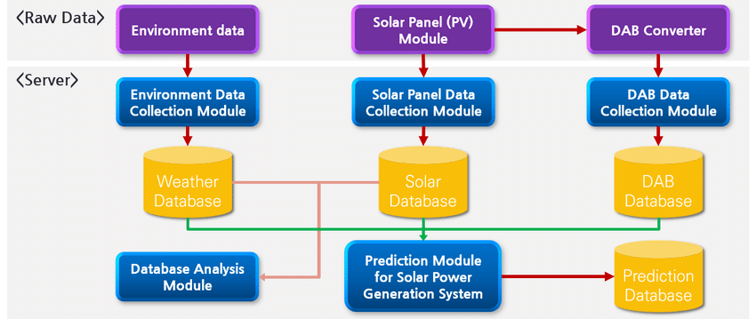Figure 1 : Architecture and data flow of solar panel forecasting